DYNAMIC SEATING ALLOCATION SYSTEM

A Project Work submitted in partial fulfilment of the

requirements for the degree of

BACHELOR OF COMPUTER APPLICATIONS

to the

PERIYAR UNIVERSITY, SALEM - 11

Submitted By

G. SURESH

# **(Reg. No. C21UG131CAP041)**

**DEPARTMENT OF COMPUTER APPLICATIONS**

**VYSYA COLLEGE**

**(AFFILIATED TO PERIYAR UNIVERSITY)**

**SALEM – 636 103**

**MARCH – 2024**

**Date:**

**CERTIFICATE**

This is to certify that the Project Work entitled **"DYNAMIC SEATING ALLOCATION SYSTEM"** submitted in partial fulfillment of the requirements of the degree of Bachelor of Computer Applications to the Periyar University, Salem is a record of bonafide work carried out by **G. SURESH** Reg. No.**C21UG131CAP041** under my supervision and guidance.

**Head of the Department Internal Guide**

**Date of Viva-voice:**

**Internal Examiner External Examiner**

**ACKNOWLEDGEMENT**

I am immensely grateful to **Thiru J. Rajendra Prasad,** Correspondent of Vysya College, Salem, for his unwavering support and invaluable guidance throughout the project. His encouragement and provision of essential information were instrumental in its successful completion.

I extend my heartfelt appreciation to **Dr. P. Venkatesan M.Sc, Ph.D.** Principalof Vysya College, Salem, for granting me the opportunity to undertake this project and for his continuous encouragement.

I am indebted to the Head of the Department of Computer Applications at Vysya College, Salem, for his insightful suggestions, innovative ideas, and constructive feedback, which greatly contributed to the project's development.

Special thanks to my guide and the dedicated faculty members of our department for their constant support and assistance during the project's execution.

I also express my gratitude to all the other faculty members and individuals who generously shared their expertise and resources, making significant contributions to the project's success.

I would like to express my special gratitude and thanks to all above mentioned people for giving us such attention and time. My thanks and appreciations also go to our other faculties in developing the project and people who have willingly helped us out with their abilities.

I sincerely appreciate the time and attention provided by everyone involved, without which this project would not have been possible.

**CONTENTS**

|  |  |
| --- | --- |
| **CHAPTER** | **PAGE NO** |
| **COLLEGE BONAFIDE CERTIFICATE**  **ACKNOWLEDGEMENT**  **SYNOPSIS** |  |
| **CHAPTER 1** | |
| **1. INTRODUCTION** | 1 |
| * 1. SYSTEM SPECIFICATION | 2 |
| 1.1.1 HARDWARE CONFIGURATION | 2 |
| 1.1.2 SOFTWARE SPECIFICATION | 2 |
| **CHAPTER 2** | |
| **2. SYSTEM STUDY** |  |
| 2.1EXISTING SYSTEM | 3 |
| 2.1.1DESCRIPTION | 3 |
| 2.1.2 DRAWBACKS | 4 |
| 2.2 PROPOSED SYSTEM | 5 |
| 2.2.1 DESCRIPTION | 5 |
| 2.2.2 FEATURES | 6 |
| **CHAPTER 3** | |
| **3. SYSTEM DESIGN AND DEVELOPMENT** |  |
| 3.1 FILE DESIGN | 7 |
| 3.2 INPUT DESIGN | 7 |
| 3.3 OUTPUT DESIGN | 8 |
| 3.4 CODE DESIGN | 8 |
| 3.5 SYSTEM DEVELOPMENT | 9 |
| 3.5.1 DESCRIPTION OF MODULES | 9 |
| **CHAPTER 4** | |
| **4. SYSTEM DESIGN AND IMPLEMENTATION** | 12 |
| **CHAPTER 5** | |
| **5. CONCLUSION** | 15 |
| 5.1 FUTURE ENHANCEMENT | 15 |
| **CHAPTER 6** | |
| **6. BIBLIOGRAPHY** | 16 |
| **APPENDICES** |  |
| 1. DATA FLOW DIAGRAM | 17 |
| 1. USE CASE DIAGRAM | 18 |
| 1. SAMPLE CODING | 19 |
| 1. SAMPLE INPUT | 37 |
| 1. SAMPLE OUTPUT | 40 |

**SYNOPSIS**

**SYNOPSIS**

The Dynamic Seating Allocation System is a software-based solution designed to streamline and optimize the process of seating arrangement for exams in college. This system leverages advanced algorithms and data analysis techniques to automate the tedious task of assigning seats to students based on various criteria. Traditionally, exam seating arrangements are manually handled, consuming significant time and effort from administrators. In our system aims to alleviate this burden by providing an efficient and accurate seating allocation process. By utilizing the power of technology, it ensures fairness, security, and convenience for both students and exam administrators. The system incorporates several key features. First, it allows administrators to define and input relevant parameters, such as the number of students, seating a capacity, and any special requirements. It then processes this information to generate optimal seating plans that satisfy constraints such as seating capacity, student preferences, and separation between certain individuals. It intelligently assigns seats to ensure fairness and prevent cheating while respecting any specific by the institution. The system also offers flexibility and adaptability. It can handle last-minute changes, such and student absences or new enrollments, and quickly generate revised seating arrangements.

**INTRODUCTION**

**CHAPTER 1**

**INTRODUCTION**

In today's rapidly changing world driven by advanced data management and automation, educational institutions face the challenge of efficiently organizing and allocating resources. Among these resources, seating arrangements for students in classrooms pose a significant logistical challenge. This project addresses these challenges by providing a simple yet effective solution designed to streamline the process for college administrators.

By using modern technology and innovative approaches, this project aims to transform the way seating arrangements are managed in learning environments. With a focus on user-friendly interfaces and intuitive workflows, the system empowers educators and administrators to create optimal seating arrangements with ease and efficiency.

In the past, assigning seats manually and dealing with paperwork was the norm. However, this project introduces a new modern age for educational institutions, using automation and digital tools to streamline the process of allocating seats. This advancement saves time and effort for everyone involved. While Excel and VBA macros have progressed to address certain needs, this project goes beyond by providing a user-friendly graphical interface. This interface improves accessibility and usability for administrators, teachers, and students, making the whole process smoother and more efficient.

**1.1 SYSTEM SPECIFICATION**

**1.1.1 Hardware Configuration**

Hardware requirements for this system are listed below:

* + System : Intel Core i5 or AMD Ryzen 5
  + HardDisk : 250 GB HDD
  + Monitor : 1280 x 720 pixels
  + RAM : 4GB
  + Keyboard : Standard Keyboard

**1.1.2 Software Specification**

Software requirements for this system are as listed

* + Operating System : Mostly Preferable (Any Windows)
  + Platform : Python Technology
  + Tool : Python 3.12/Visual Studio Code
  + Frontend : PyQt5,Tkinter,DataFrames
  + Backend : Python, Excel Sheet

**SYSTEM STUDY**

**CHAPTER 2**

**SYSTEM STUDY**

**2.1 EXISTING SYSTEM**

* The existing system in our college relies on Excel coupled with VBA macros for seating arrangements. This system typically involves manually inputting student data, room specifications, and seating preferences into Excel spreadsheets, with VBA macros automating certain aspects of the allocation process.
* The system allows for highly customizable seating arrangements tailored to specific exam formats, room layouts, and scheduling requirements
* VBA macros automate repetitive tasks, such as assigning students to seats based on predefined criteria and generating seating charts or reports. This automation enhances efficiency and reduces the time and effort required for manual seat allocation.
* The system's functionality may be dependent on individual expertise in Excel and VBA programming. Staff turnover or changes in personnel could disrupt the continuity and maintenance of the system, leading to potential inefficiencies or errors.

**2.1.1 DESCRIPTION**

* While the existing system requires users to manually input student data and room specifications into Excel sheets, my project provides a graphical user interface (GUI) that simplifies this process. Instead of navigating complex spreadsheets and writing VBA macros, users can input data effortlessly using intuitive forms and menus.
* Furthermore, the existing system's reliance on VBA macros for automation poses challenges for users who lack programming skills or familiarity with Excel. In contrast, my project eliminates the need for VBA programming by offering built-in algorithms and automation features accessible through the GUI. This approach enhances accessibility and usability for all users, regardless of their technical expertise.
* Overall, my current project represents a significant improvement over the existing system by offering a modern, user-friendly, and automated solution for seating arrangement management in our college.

**2.1.2 DRAWBACKS:**

While the existing system with Excel and Macros/VBA may have served its purpose to some extent, it is not without its drawbacks:

1. **Limited Scalability:**

The existing system's reliance on Excel and VBA macros may limit its scalability, especially when dealing with large datasets or complex seating arrangements. As the volume of data increases, the performance of Excel may degrade, resulting in slower processing times and reduced efficiency.

1. **Dependency on Technical Expertise:**

Operating and maintaining the existing system requires a certain level of technical expertise, particularly in VBA programming.

1. **Complexity:**

Managing large datasets and seating configurations in Excel can be complex and cumbersome, particularly for administrators without advanced Excel skills.

**2.2 PROPOSED SYSTEM**

The proposed system is a modern, user-friendly software application designed to revolutionize the process of seating arrangement management in educational institutions. Unlike the existing system, which relies on manual data entry and limited automation through Excel and VBA macros, the proposed system offers a comprehensive solution with advanced features and enhanced usability .

**2.2.1 DESCRIPTION**

* Imagine a system where you can easily input exam details, such as the number of students and available rooms, using a familiar and intuitive interface. With just a few clicks, you can define seating preferences and let the system handle the rest.
* This system is all about automation. It takes care of assigning seats to students based on various factors like room capacity and special requirements, so you don't have to worry about manual calculations or errors keeping in.

**2.2.2 FEATURES**

1. **Excel Data Processing:**

The system allows users to import student data from Excel files, ensuring compatibility with existing data sources.

1. **Efficient Data Allocation:**

Utilizing Python and pandas, the system processes and allocates student seats in a more efficient and optimized manner.

1. **User-Friendly Interface:**

A Tkinter-based graphical user interface (GUI) makes the system accessible to users with varying technical expertise, reducing dependency on specialized skills.

1. **Error Reduction:**

Automation minimizes the risk of human errors, enhancing the accuracy of student seat allocation.

1. **Quick Generation of Seating Arrangements:**

The system generates seating arrangements swiftly, saving time for educators and administrators.

1. **Flexibility for Modifications:**

Changes in student enrollment or classroom setups can be easily accommodated through the system's adaptable design.

1. **Output in Excel Format:**

The final seating arrangement is exported to Excel, providing a familiar and widely used format for easy integration into existing workflows

**SYSTEM DESIGN AND DEVELOPMENT**

**CHAPTER 3**

**SYSTEM DESIGN AND DEVELOPMENT**

**3.1 FILE DESIGN**

The file design of a student seat allocation system is essential for effectively managing student data, room information, and the seating arrangement process. It involves organizing data into structured files that facilitate efficient storage, retrieval, and manipulation of information. A well-designed file structure ensures the integrity, security, and accessibility of data throughout the seat allocation process.

**3.2 INPUT DESIGN**

The input file for the student seat allocation system is an Excel spreadsheet (.xlsx). It's like a table where each column represents a different department, like "BCA" or "MATHS". In each department's column, you'll see a list of students, with each student listed on a separate row. Every column shows the student's unique register number, which helps to identify them. This organized setup makes it easy to find and manage student information, which is important for assigning seats during the allocation process. During the allocation process, the input file will be read by alternative columns, with odd columns read alone and even columns read alone. It's essential to ensure that the input file remains consistent throughout this process.

**3.3 OUTPUT DESIGN**

The student seat allocation system provides seating arrangements in two formats: Excel and PDF.

In the Excel format, seating arrangements are organized like tables in a spreadsheet (.xlsx). Each sheet represents a different class or room in the exam venue. Students are assigned specific seats, displayed in rows and columns with students' register numbers are listed in the cells. This layout helps manage student information efficiently and ensures clear seat assignments. Room numbers are also included for easy identification of exam rooms. It's important to keep the data consistent throughout the process.

The PDF format presents seating arrangements in a visually appealing way. Each page of the PDF corresponds to a specific class or room in the exam hall. Seats are arranged in rows and columns, with students' register numbers listed next to each seat. The PDF includes headers with essential information such as the college name, exam details, and signatures of hall supervisors and principals at the bottom of each page. This format offers a straightforward and comprehensive overview of the seating arrangement, making exam management easier.

**3.4 CODE DESIGN**

At the code implies, the student seat allocation system is like a smoothly running code, made up of different parts that work together seamlessly. First, it gathers information about students and the available rooms from files, like Excel sheets. Then, it uses a smart algorithm to figure out where each student should sit. This decision is based on things like how big the room is and how many students there are.Top of Form Once the seats are assigned, the system creates a clear seating plan. This could be in the form of Excel sheets or PDFs, making it easy to see where each student should go. If something goes wrong along the way, the system handles it gracefully. It gives clear messages to help understand and fix any issues that arise.

**3.5 SYSTEM DEVELOPMENT**

System development encompasses the entire process of creating, implementing, and maintaining software systems to fulfill specific requirements. It begins by comprehending the users' needs and strategizing how to fulfill them, which involves setting objectives, scheduling tasks, and determining resource requirements.

It is a structured approach to creating and improving software systems to meet specific needs. It starts with understanding what the college administrators needed. It involved planning out each step carefully to make sure everything would work well. As the only developer, I had to think through everything and turn ideas into reality. Testing was important to make sure everything worked smoothly. Finally, the system was ready for use by the administrators, meeting their needs effectively.

**3.5.1 DESCRIPTION OF MODULES**

The modules of the project are:

* Login Module
* Signup Module
* Room Specification
* Generate Excel Output
* Generate PDF Output

**Login Module:**

The login module is the gateway for administrators to access the system securely. Here's how it works:

* Administrators need to enter their username and password in the designated fields provided on the screen. Once they've filled in their details, they can click the "Sign in" button.
* To make it easier, there's a checkbox that allows administrators to show or hide their password while typing.
* If administrators make a mistake and enter the wrong username or password, the system will show them an error message to let them know and ask them to try again with the correct details.

**Signup Module:**  
 The sign-up module serves as a platform for new users to register and create an account within the system.

* It provides a user-friendly interface where individuals can input their desired username and password.
* Upon submission, the system ensures that the entered passwords match correctly before proceeding further. In case of any discrepancies, such as mismatched passwords, custom error dialogs are displayed to notify the user about the issue.
* Valid user credentials are securely stored in a text file for future authentication. Once the registration process is successfully completed, users receive confirmation through a custom information dialog.

**Room Specification:**

The room specification module facilitates the configuration of exam rooms within the system.

* It offers a user-friendly interface where administrators can define various parameters related to each exam room, such as room number, capacity, and seating arrangement.
* Administrators can input details such as the room number and the maximum capacity of students allowed in each room.
* Additionally, they can specify the layout of the seating arrangement, including the number of rows and columns in the room.

**Generate Excel Output**

This module is responsible for creating structured Excel spreadsheets that contain the seating arrangements for the exam halls.

* This module takes the allocated seats data and organizes it into an Excel file format (.xlsx), making it easy to manage and distribute.
* The process begins by gathering the allocated seating information from the system's Excel Sheet.
* Then, using the openpyxl library and pandas in Python, the module generates an Excel workbook with multiple sheets, each representing a different exam hall or room.
* Within each sheet, the seating arrangement is laid out in a tabular format, with rows and columns corresponding to the seats in the room
* The student's registration number is placed in each cell to denote their allocated seat.

**Generate PDF Output**

* This module transforms the allocated seating data into PDF documents, which are easy to distribute and view across different devices.
* The process begins by gathering the allocated seating information from the system's Excel Sheet , similar to the Excel output module.
* Using a PDF generation library such as ReportLab and PyFPDF in Python, the module creates PDF files containing the seating arrangements.
* The seating arrangement is presented in a structured layout, with rows and columns representing individual seats
* Each seat is labeled with the student's unique identifier or registration number to indicate their allocated position.
* The PDF output may include other relevant details such as the room number, exam date, and supervisor instructions.

**SYSTEM DESIGN AND IMPLEMENTATION**

**CHAPTER 4**

**SYSTEM DESIGN AND IMPLEMENTATION**

**TESTING**

Testing is the ultimate step of software development. Testing software extend towards coding phase and it represents the ultimate review of configuration, design, coding. A series of test cases are created that are intended to demolish the component that has been built. It is essential that all components of an application be tested, as the failure to do so many results in a series of bugs after the software id put to use.

**SOFTWARE TESTING**

Software testing is the process used to measure the quality of developed computer software. Usually, quality is constrained to such topics as correctness, completeness, security, but can also include more technical requirements as described under the ISO standard ISO 9126, such as capability, reliability, efficiency, portability, maintainability, compatibility, and usability. Testing is a process of technical investigation, performed on behalf of stakeholders, that is intended to revel quality-related information about product with respect to the context in which it is intended to operate.

**TESTING SOFTWARE MODULES**

It characterized as a process of investigating a software and identifying the difference and among the actual and obliged conditions and also to validate the characteristics of the system or component. It can be described as an action of eliminating the software errors from an application. The process of testing is nothing but determining the errors in an application. Activity time the software advance. list is being performed next to using several test cases and using these exams by checking how it works is evaluated headed prove if applications by functioning according in the direction of user obligement or not. Software tough be the most important activity that exhibits the final analysis of design and code generation.

Following testing types are performed after coding.

* Unit Testing
* Integration Testing
* Functionality Testing

**UNIT TESTING**

Unit testing is implemented to evaluate individual units or components of the project, such as functions, methods, or classes, in isolation. Each unit is tested independently to verify its correctness and functionality, ensuring that it behaves as intended and produces the expected output for a given set of inputs. In unit testing, the focus is on testing small, atomic units of code, typically at the function or method level, to ensure they perform as expected and meet the specified requirements. This approach allows for the early detection and resolution of defects, promoting code reliability and maintainability.

**INTEGRATION TESTING**

Integration testing focuses on testing how different units or components of the project interact and work together when integrated into the system. This testing ensures that the integration of various modules does not introduce any unexpected behavior or errors and that the system functions seamlessly as a whole.

Integration tests are designed to validate the flow of data and control between different modules, ensuring that data is passed correctly between components and that the overall system behavior meets the specified requirements.

During integration testing, various modules or components are integrated incrementally, and their interactions are examined to detect any inconsistencies, interface mismatches, or communication issues.

**FUNCTIONALITY TESTING**

Functionality testing assesses the overall functionality of the project by validating its features and capabilities against the specified requirements. This testing ensures that all functionalities work as intended, perform their intended tasks accurately, and meet the user's expectations.

Verify that administrators can securely log in to the system using their credentials and access the necessary functionalities.

Test the system's ability to allocate seats to students based on predefined criteria, such as exam schedules, seating capacity, and special accommodations.

Ensure that seats are assigned accurately and efficiently, considering factors like student preferences, accessibility requirements, and exam regulations.

**SYSTEM DEVELOPMENT**

Implementation of modified application to replace an existing one. This type of conversation is relatively easy to handle, provide there are no major changes in the system. Each program is tests individually at the time of development using the data and has verified that this program linked together in the way specified in the programs specification, the computer system and its environments is tested to the satisfaction of the user. The system that has been developed is accepted and proved to be satisfactory for the user. And so, the system is going to be implemented very soon

**CONCLUSION**

**CHAPTER 5**

**CONCLUSION**

The DYNAMIC SEATING ALLOCATION SYSTEM project was a journey of understanding, planning, and implementation to meet the needs of college administrators effectively. Through meticulous analysis, thoughtful design, and thorough testing, we ensured that the system met its objectives of simplifying exam hall management.

**5.1 FUTURE ENHANCEMENT**

* + For future improvements, we can make the DYNAMIC SEATING ALLOCATION SYSTEM better in a few ways. One idea is exploring features such as dynamic seating allocation algorithms to optimize space utilization and accommodate varying exam schedules efficiently.
  + Moreover, integrating a notification system to alert students about their allocated seats and exam details in real-time could enhance user experience and reduce administrative workload.

**BIBILOGRAPHY**

**CHAPTER 6**

**BIBILOGRAPHY**

**For Python**

<https://www.w3schools.com/python/>

**For PyQT5**

<https://doc.qt.io/qtforpython-6/quickstart.html>

**For Tkinter**

<https://www.geeksforgeeks.org/python-gui-tkinter/>

**Book:**

1. Skiena, S. S. (2008). Algorithm Design Manual. Springer.

**APPENDICES**

1. **DATA FLOW DIAGRAM**

**ADMIN FLOW DIAGRAM**

FILL THE OTHER NECESSARY INFORMATION

SEATING ARRANGEMENT ALGORITHM

GENERATE OUTPUT AS PDF FORMAT OR EXCEL FORMAT

ADMIN/USER

LOGIN

ADMIN/USER UPLOAD THE STUDENTS REGISTER NUMBER EXCEL SHEET

1. **USE CASE DIAGRAM**

**C. SAMPLE CODING**

**Main.py**

from PyQt5.QtWidgets import QApplication, QWidget, QPushButton, QVBoxLayout, QFileDialog, QMessageBox

from PyQt5.QtCore import Qt

from design_module import DesignModule

from allocation_module import AllocationModule

from pdf_module import PdfModule

import sys

class MainProgram(QWidget):

def __init__(self):

super().__init__()

self.design_module = DesignModule(self)

self.allocation_module = AllocationModule(self)

self.init_ui()

def init_ui(self):

self.setWindowTitle('Classroom Generator')

self.setGeometry(100, 100, 400, 300)

layout = QVBoxLayout(self)

layout.addWidget(self.design_module)

self.generate_excel_button = QPushButton('Generate Excel Output', self)

self.generate_excel_button.clicked.connect(self.generate_excel_output)

layout.addWidget(self.generate_excel_button)

self.generate_pdf_button = QPushButton('Generate PDF Output', self)

self.generate_pdf_button.clicked.connect(self.generate_pdf_output)

layout.addWidget(self.generate_pdf_button)

def generate_excel_output(self):

file_path = self.design_module.file_entry.text()

students_per_class_text = self.design_module.class_entry.text()

rows_text = self.design_module.rows_entry.text()

columns_text = self.design_module.columns_entry.text()

if not all([file_path, students_per_class_text, rows_text, columns_text]):

QMessageBox.critical(self, 'Error', 'Please fill in all the input fields.')

return

try:

students_per_class = int(students_per_class_text)

rows = int(rows_text)

columns = int(columns_text)

except ValueError:

QMessageBox.critical(self, 'Error', 'Please enter valid numerical values for students per class, rows, and columns.')

return

l3, _ = self.allocation_module.read_excel_and_generate_output(file_path, students_per_class)

self.allocation_module.generate_excel_output(l3, students_per_class, rows, columns)

def generate_pdf_output(self):

try:

file_path = self.design_module.file_entry.text()

students_per_class_text = self.design_module.class_entry.text()

rows_text = self.design_module.rows_entry.text()

columns_text = self.design_module.columns_entry.text()

exam_name = self.design_module.exam_name_combobox.currentText()

exam_date = self.design_module.date_edit.date().toString(Qt.DefaultLocaleLongDate)

session = self.design_module.session_combobox.currentText()

college_name = self.design_module.get_college_name() #College Name

if not all([file_path, students_per_class_text, rows_text, columns_text]):

QMessageBox.critical(self, 'Error', 'Please fill in all the input fields.')

return

try:

students_per_class = int(students_per_class_text)

rows = int(rows_text)

columns = int(columns_text)

except ValueError:

QMessageBox.critical(self, 'Error', 'Please enter valid numerical values for students per class, rows, and columns.')

return

if rows * columns != students_per_class:

QMessageBox.critical(self, 'Error', 'The specified number of rows and columns is not sufficient to accommodate the students per class.')

return

l3, _ = self.allocation_module.read_excel_and_generate_output(file_path, students_per_class)

pdf = PdfModule.generate_pdf_output(l3, students_per_class, rows, columns, exam_name, exam_date,session,college_name)

options = QFileDialog.Options()

options |= QFileDialog.DontUseNativeDialog

filename, _ = QFileDialog.getSaveFileName(self, "Save PDF file", "AllocatedStudents.pdf", "PDF Files (*.pdf);;All Files (*)", options=options)

if filename:

pdf.output(filename)

QMessageBox.information(self, 'Success', f'PDF file "{filename}" has been created successfully.')

except Exception as e:

QMessageBox.critical(self, 'Error', f'An error occurred: {str(e)}')

print(f'An error occurred: {str(e)}')

def main():

app = QApplication(sys.argv)

window = MainProgram()

window.show()

sys.exit(app.exec_())

if __name__ == '__main__':

main()

**SignUp.py**

from tkinter import *

from tkinter import messagebox

import ast

import tkinter as tk

from tkinter import Toplevel, Label, Button, Entry

from PIL import Image, ImageTk

window=Tk()

window.title("EXAM HALL SEATING ARRANGEMENT")

window.geometry('925x500+300+200')

window.configure(bg='#fff')

window.resizable(False,False)

window.iconbitmap(r'C:\Users\sures\OneDrive\Desktop\Exam Seat\Assests\img\logoico.ico')

def show_custom_error(title, message):

error_dialog = Toplevel()

error_dialog.title(title)

error_dialog.iconbitmap(r"C:\Users\sures\OneDrive\Desktop\Exam Seat\Assests\img\logoico.ico")

error_dialog.geometry('400x150+500+300')

error_dialog.configure(bg='#c0392b') # Set background color to light red

error_dialog.resizable(False, False)

Label(error_dialog, text=message, fg='#f5f6fa', bg='#c0392b', font=('Arial', 14, 'bold')).pack(pady=5)

def close_dialog():

error_dialog.destroy()

# Resume background tasks here

Button(error_dialog, text='OK', command=close_dialog, bg='#0652DD', fg='white', font=('Arial', 14, 'bold')).pack(pady=30)

# Make the error dialog modal

error_dialog.grab_set()

# Wait until the error dialog is closed before continuing with the background tasks

error_dialog.wait_window()

def show_custom_info(title, message):

info_dialog = Toplevel()

info_dialog.title(title)

info_dialog.iconbitmap(r"C:\Users\sures\OneDrive\Desktop\Exam Seat\Assests\img\logoico.ico")

info_dialog.geometry('400x150+500+300')

info_dialog.configure(bg='#1abc9c') # Set background color to light green

info_dialog.resizable(False, False)

Label(info_dialog, text=message, fg='#f5f6fa', bg='#1abc9c', font=('Arial', 14, 'bold')).pack(pady=5)

def close_dialog():

info_dialog.destroy()

# Resume background tasks here

Button(info_dialog, text='OK', command=close_dialog, bg='#0652DD', fg='white', font=('Arial', 14, 'bold')).pack(pady=30)

# Make the info dialog modal

info_dialog.grab_set()

# Wait until the info dialog is closed before continuing with the background tasks

info_dialog.wait_window()

def signup():

username = user.get()

password = code.get()

confirm_password = confirm_code.get()

if password == confirm_password:

try:

file = open('datasheet.txt', 'r+')

d = file.read()

r = ast.literal_eval(d)

dict2 = {username: password}

r.update(dict2)

file.truncate(0)

file.close()

file = open('datasheet.txt', 'w')

w = file.write(str(r))

show_custom_info('SignUp', 'Successfully Signed Up')

except:

file = open('datasheet.txt', 'w')

pp = str({'Username': 'Password'})

file.write(pp)

file.close()

else:

show_custom_error('Incorrect', 'Password should not match')

def sign():

window.destroy()

# Load and display the background image

try:

pil_image = Image.open(r'C:\Users\sures\OneDrive\Desktop\Exam Seat\Assests\img\bg1.jpg')

img = ImageTk.PhotoImage(pil_image)

label = Label(window, image=img)

label.place(x=0, y=0, relwidth=1, relheight=1)

except Exception as e:

print(f"An error occurred: {e}")

# Create a custom title bar

title_bar = tk.Frame(window, bg='#1abc9c', height=30)

title_bar.pack(fill='x')

# Create a label for the title

title_label = tk.Label(title_bar, text='SignUp Page', bg='#1abc9c', fg='white', font=('Helvetica', 12,'bold'))

title_label.pack(side='left', padx=10)

#Create Frame

frame=Frame(window,width=350,height=390,bg='white')

frame.place(x=480,y=50)

heading = tk.Label(frame, text='Sign Up', fg='#1abc9c', bg='white', font=('Microsoft Vahei UI L', 23, 'bold'))

heading.place(x=120, y=5)

###-------------------------------------------------------------------------------------------------------------

def on_enter(e):

user.delete(0,'end')

def on_leave(e):

if user.get()=='':

user.insert(0,'Username')

user=Entry(frame,width=25,fg='black',border=0,bg='white',font=('Microsoft Vahei UI L', 11))

user.place(x=30,y=80)

user.insert(0,'Username')

user.bind('<FocusIn>',on_enter)

user.bind('<FocusOut>',on_leave)

Frame(frame,width=295,height=2,bg='black').place(x=25,y=107)

###-------------------------------------------------------------------------------------------------------------

def on_enter(e):

code.delete(0,'end')

def on_leave(e):

if code.get()=='':

code.insert(0,'Password')

code=Entry(frame,width=25,fg='black',border=0,bg='white',font=('Microsoft Vahei UI Light', 11))

code.place(x=30,y=150)

code.insert(0,'Password')

code.bind('<FocusIn>',on_enter)

code.bind('<FocusOut>',on_leave)

Frame(frame,width=295,height=2,bg='black').place(x=25,y=177)

###-------------------------------------------------------------------------------------------------------------

def on_enter(e):

confirm_code.delete(0,'end')

def on_leave(e):

if confirm_code.get()=='':

confirm_code.insert(0,'Confirm Password')

**Allocation_module.py**

# allocation_module.py

import pandas as pd

from PyQt5.QtWidgets import QMessageBox, QFileDialog

from openpyxl.styles import Alignment

from openpyxl.utils import get_column_letter

from openpyxl import Workbook

from openpyxl.utils.dataframe import dataframe_to_rows

class AllocationModule:

def __init__(self, parent):

self.parent = parent

def read_excel_and_generate_output(self, file_path, students_per_class):

df = pd.read_excel(file_path, header=None)

l1 = []

l2 = []

for i in range(0, df.shape[1], 2):

l1.extend(df.iloc[:, i].dropna().tolist())

l2.extend(df.iloc[:, i + 1].dropna().tolist())

len_diff = len(l1) - len(l2)

if len_diff > 0:

num_to_append = len_diff // 2

l2.extend(l1[-num_to_append:])

l1 = l1[:-num_to_append]

elif len_diff < 0:

num_to_append = abs(len_diff) // 2

l1.extend(l2[-num_to_append:])

l2 = l2[:-num_to_append]

if len_diff % 2 == 1:

last_element_l2 = l2.pop()

l2.reverse()

l3 = [item for pair in zip(l1, l2) for item in pair]

if len_diff % 2 == 1:

l3.append(last_element_l2)

return l3, students_per_class

def generate_excel_output(self, l3, students_per_class, rows, columns):

data = {'Student_ID': l3}

df_output = pd.DataFrame(data)

students_total = len(l3)

classes = -(-students_total // students_per_class)

if rows * columns < students_per_class:

QMessageBox.critical(self.parent, 'Error', 'The specified number of rows and columns is not sufficient to accommodate the students per class.')

return

remaining_slots = students_per_class * classes - students_total

l3 += ['NONE'] * remaining_slots

options = QFileDialog.Options()

options |= QFileDialog.DontUseNativeDialog

filename, _ = QFileDialog.getSaveFileName(self.parent, "Save Excel file", "AllocatedStudents.xlsx", "Excel Files (*.xlsx);;All Files (*)", options=options)

if filename:

if not filename.endswith(".xlsx"):

filename += ".xlsx"

wb = Workbook()

for i in range(classes):

start_row = i * students_per_class

end_row = min((i + 1) * students_per_class, students_total)

class_data = df_output.iloc[start_row:end_row]

if not class_data.empty:

none_values = pd.DataFrame({'Student_ID': ['NONE'] * (students_per_class - len(class_data))})

class_data = pd.concat([class_data, none_values], ignore_index=True)

reshaped_data = class_data.values.reshape((rows, columns), order='F')

reshaped_df = pd.DataFrame(reshaped_data)

reshaped_df.columns = [f'Room {j + 1}' for j in range(reshaped_df.shape[1])]

ws = wb.create_sheet(title=f'Class_{i + 1}')

for col in range(1, reshaped_df.shape[1] + 1):

column_letter = get_column_letter(col)

ws.column_dimensions[column_letter].width = 19

for r in dataframe_to_rows(reshaped_df, index=False, header=True):

ws.append(r)

ws.merge_cells(start_row=1, start_column=1, end_row=1, end_column=columns)

cell = ws.cell(row=1, column=1)

cell.value = f'Room {i + 1}'

cell.alignment = Alignment(horizontal='center')

default_sheet = wb.active

wb.remove(default_sheet)

wb.save(filename)

QMessageBox.information(self.parent, 'Success', f'Excel file "{filename}" has been created successfully.')

**Pdf_module.py**

from fpdf import FPDF

from PyQt5.QtWidgets import QMessageBox

class PdfModule:

@staticmethod

def generate_pdf_output(l3, students_per_class, rows, columns, exam_name, exam_date,session,college_name):

hall_supervisor_signature = "Hall Supervisor Signature"

principal_signature = "Principal Signature"

class CustomPDF(FPDF):

def __init__(self, hall_supervisor_signature="Hall Supervisor Signature", principal_signature="Principal Signature"):

super().__init__()

self.hall_supervisor_signature = hall_supervisor_signature

self.principal_signature = principal_signature

def footer(self):

self.set_y(-12)

self.set_font("Arial", style='I', size=8)

self.set_text_color(128, 128, 127) # Gray color

self.cell(0, 10, "Developed by @Suresh G", 0, 0, 'C')

pdf = CustomPDF(hall_supervisor_signature, principal_signature)

pdf.set_auto_page_break(auto=True, margin=15)

pdf.set_font("Arial", size=7)

students_total = len(l3)

classes = -(-students_total // students_per_class)

for i in range(classes):

start_row = i * students_per_class

end_row = min((i + 1) * students_per_class, students_total)

class_data = l3[start_row:end_row]

pdf.add_page(orientation='L') # Set orientation to landscape

college_name = college_name.upper() # Convert college name to uppercase

# Add Title: COLLEGE NAME

pdf.set_font("Arial", style='B', size=26)

pdf.cell(270, 10, txt=college_name, ln=True, align='C') # Adjust width for landscape

pdf.set_font("Arial", size=7)

# Add Title: Exam HALL Seating Arrangement

pdf.set_font("Arial", style='B', size=18)

pdf.cell(270, 10, txt='EXAM HALL SEATING ARRANGEMENT', ln=True, align='C') # Adjust width for landscape

pdf.set_font("Arial", size=7)

# Add Examination Name

pdf.set_font("Arial", style='B', size=16)

pdf.cell(270, 10, txt=exam_name, ln=True, align='C') # Adjust width for landscape

# Add ROOM Title

pdf.set_font("Arial", style='B', size=12)

room_title = f'ROOM {i + 1}'

pdf.cell(270, 10, txt=room_title, ln=True, align='C') # Adjust width for landscape

# Add Date

x_left = 10 # Set left margin

y_top = 50 # Set top margin

pdf.set_font("Arial", style='B', size=10)

pdf.text(x_left, y_top, f"Date: {exam_date}") # Draw the date

x_left = 255 # Set left margin

y_top = 50 # Set top margin

pdf.set_font("Arial", style='B', size=10)

pdf.text(x_left, y_top, f"Session : {session}") # Add Session

total_tables = -(-len(class_data) // (rows * columns))

for table_index in range(total_tables):

pdf.ln()

# Add column headers with bold font

x_center = (pdf.w - 275) / 2 # Calculate the x-coordinate to center the table horizontally

pdf.set_x(x_center)

pdf.set_font("Arial", style='B', size=8)

for col_header in range(1, columns + 1):

pdf.cell(33.75, 10, txt=f'Column {col_header}', border=1, ln=0, align='C') # Adjust width for landscape

if col_header % 2 == 0 and col_header != columns: # Add space after every second column except the last one

pdf.cell(2.5, 10, '', ln=0) # Add a small gap between columns

pdf.set_font("Arial", style='B',size=7)

pdf.ln()

cell_height = 15

cell_width = 28.75

# Move to the center of the page before drawing the table

pdf.set_x(x_center)

serial_number = 1 # Initialize serial number

for row in range(rows): # Iterate over rows first

pdf.ln()

for col in range(columns): # Then iterate over columns

index = table_index * (rows * columns) + row + col * rows

if index < len(class_data):

student_id = class_data[index]

# Add serial number for each cell

serial_number = col * rows + row + 1

pdf.cell(5, cell_height, txt=str(serial_number), border=1, ln=0, align='C')

pdf.cell(cell_width, cell_height, student_id, 1, 0, 'C')

# Add extra space after every two columns

if col % 2 == 1 and col != columns - 1: # Add space after every second column except the last one

pdf.cell(2.5, 0, '', ln=0) # Add a small gap between columns

else:

serial_number = col * rows + row + 1

pdf.cell(5, cell_height, str(serial_number), 1, 0, 'C') # Empty cell for serial number

pdf.cell(cell_width, cell_height, '', 1, 0, 'C') # Empty cell

if col % 2 == 1 and col != columns - 1: # Add space after every second column except the last one

pdf.cell(2.5, 0, '', ln=0) # Add a small gap between columns

pdf.ln()

# Add signatures after drawing the tables

x_signature = 10

y_signature = pdf.h - 45 # Ensure y-coordinate is within the page height

pdf.set_font("Arial", style='B', size=10)

pdf.text(x_signature, y_signature, pdf.hall_supervisor_signature) # Access class attribute using instance

x_principal_signature = pdf.w - pdf.get_string_width(pdf.principal_signature) - 10

pdf.text(x_principal_signature, y_signature, pdf.principal_signature) # Access class attribute using instance

return pdf

**D. SAMPLE INPUT**

**Login Page**

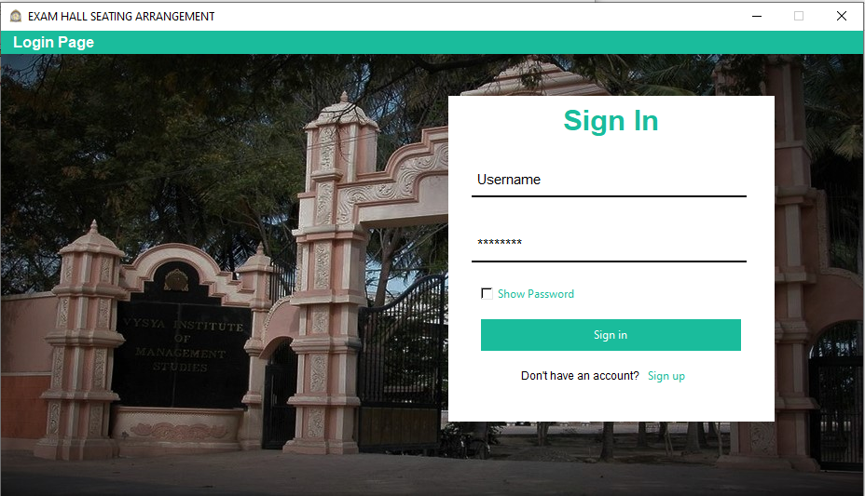

**SignUp Page**

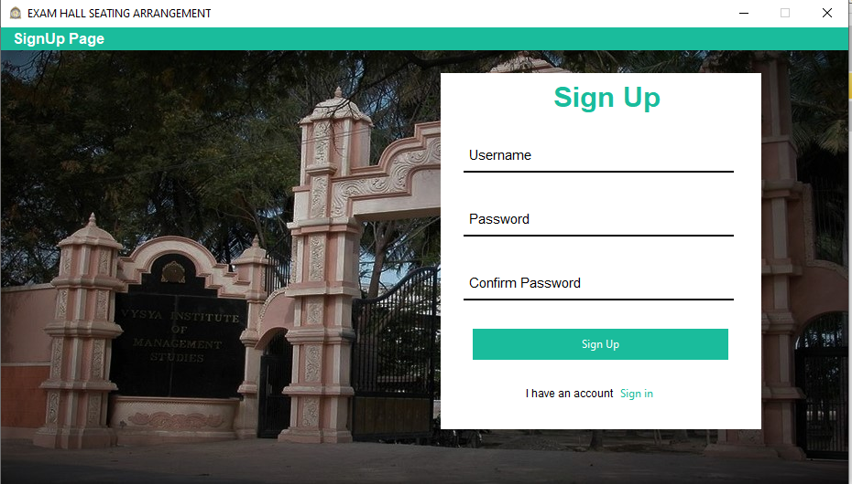

**Allocation Module**

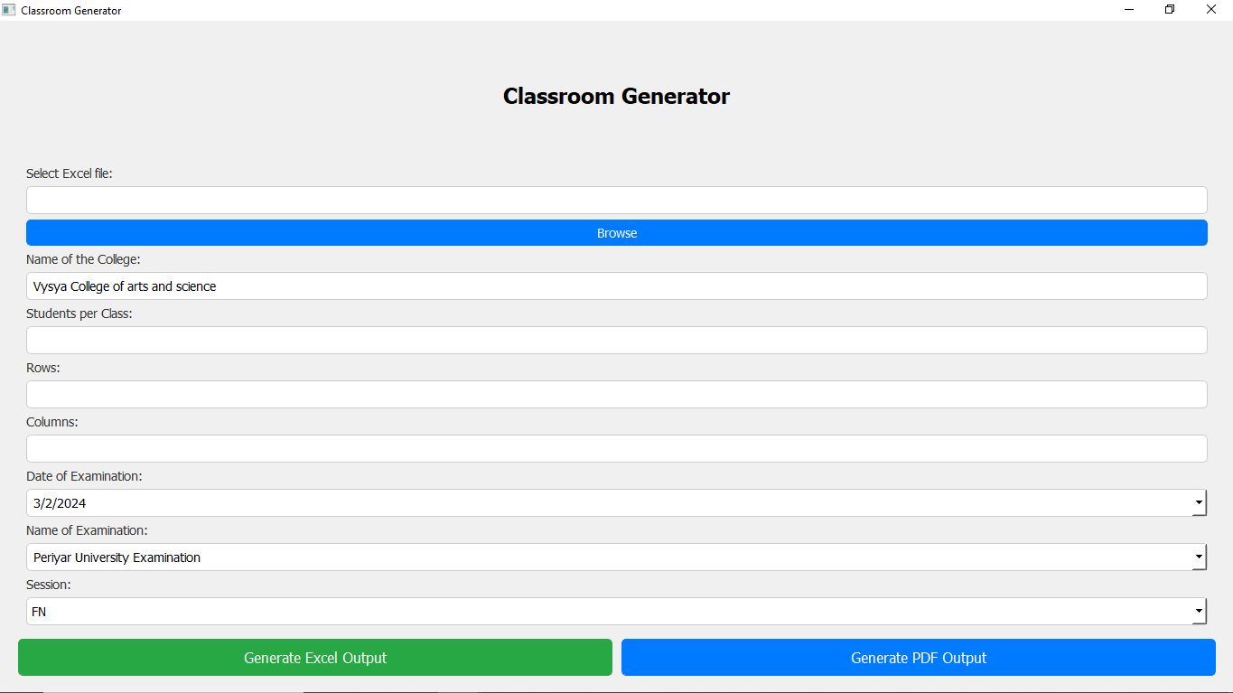

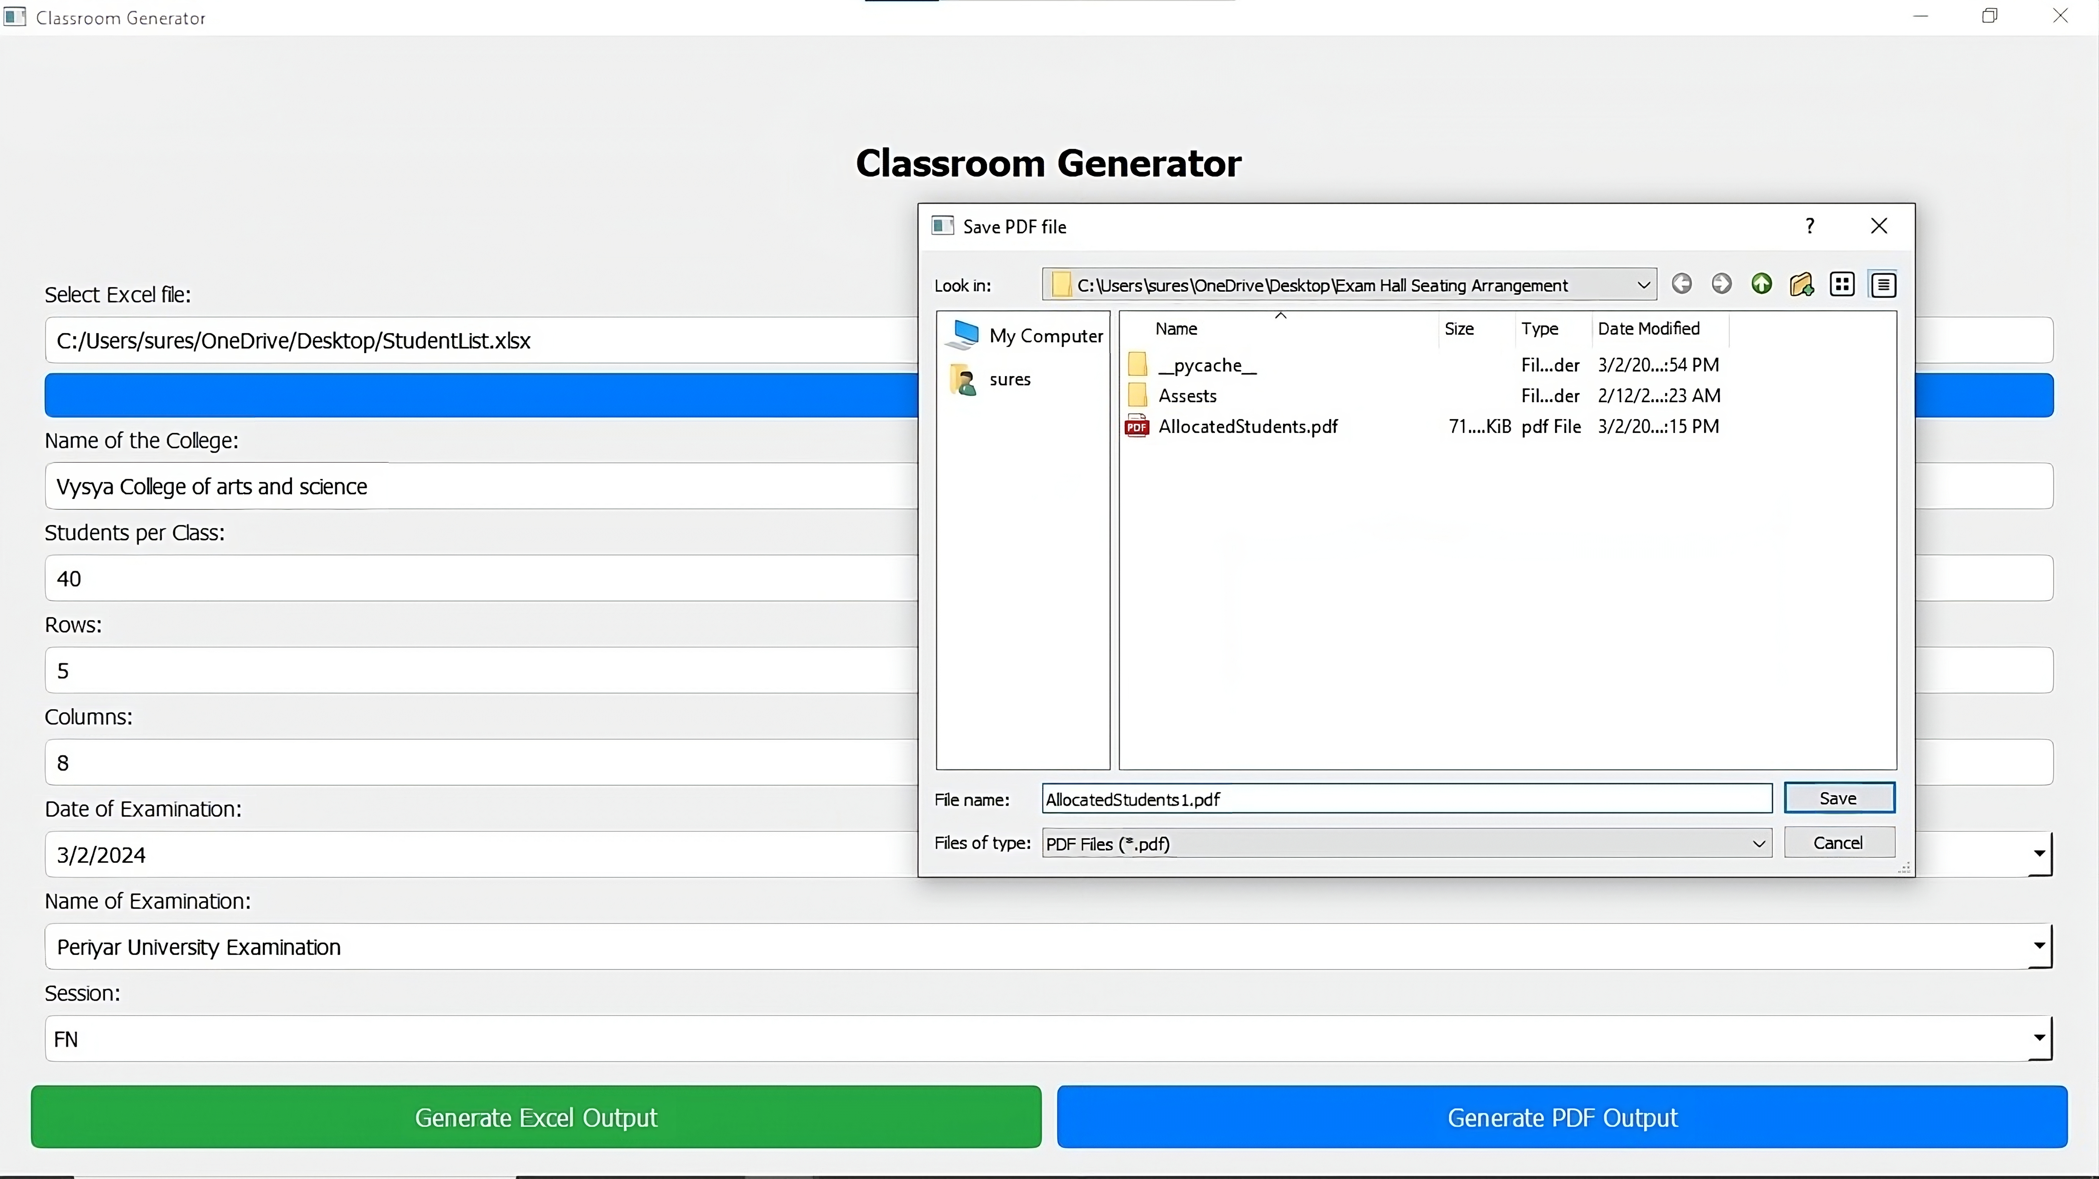

**EXCEL INPUT**

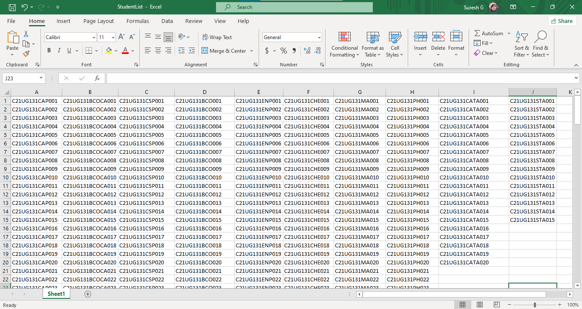

**E. SAMPLE OUTPUT:**

**PDF OUTPUT**

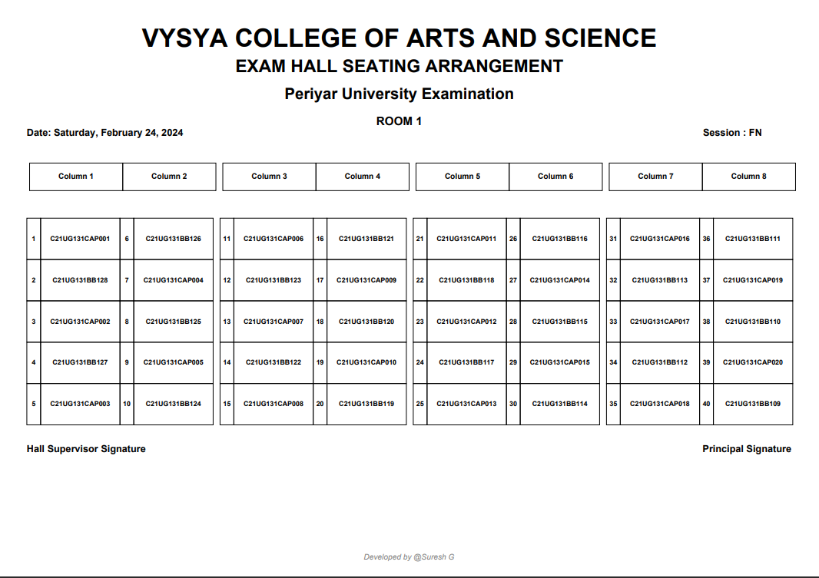

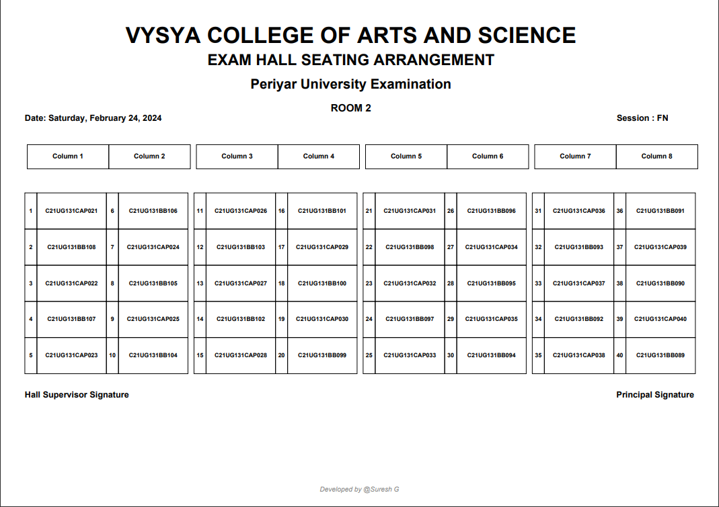

**EXCEL OUTPUT**

